How to troubleshoot a fiori Application.

The purpose of this document is to help technical and non technical person to troubleshoot the different issues we can find with Fiori apps.

For this document we will consider the case where we have a sap environement with a frontEnd (that carries the Fiori system) and a Backend System, and we will only focus on issues on Fiori applications issues.

Part 1 : Logon issue

* Login/Password issue : Check the SU01 on the frontEnd system
* If the login/password is correct and the user is not locked, but the user after logon, is sent back to the logon screen, check if the ALIAS field in SU01 is properly populated on frontEnd system

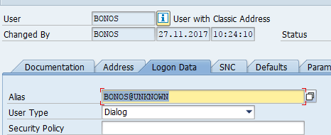

* Blank screen after logon

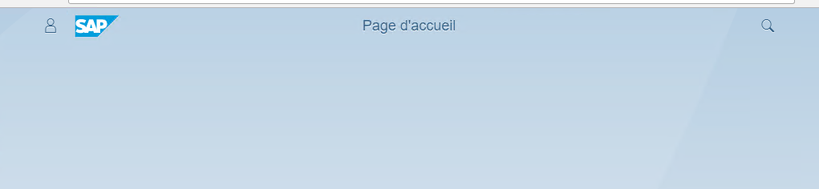

First, check the role attached to your user on the FrontEnd, to see if it is properly populated.

If the role is properly populated go to [app troubleshooting] to check if an application is not blocking the FioriLaunchpad startup

* Broken theme issue :

If there is an issue with the selected theme, you might not be able to change the theme using the fiori Launchpad function.

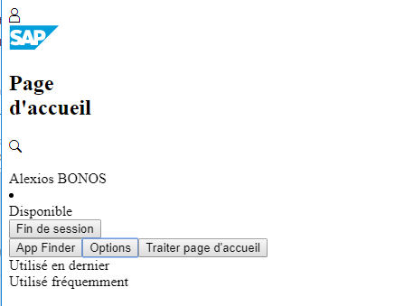

In this case you can add at the end of the URL the theme to use :

?sap-theme=sap_belize (if there is not « ? » already in the URL)

&ap-theme=sap_belize (if there is already a « ? » in the URL)

Then in the setting, set a different theme and save to set it as the new default theme.

Part 2 : Tile Missing

In Fiori the groups and tiles an user have access to is linked to his roles in the frontEnd.

You can find SAP standard roles, business catalogs and business groups linked to any tiles in the Fiori Library :

https://fioriappslibrary.hana.ondemand.com/sap/fix/externalViewer/

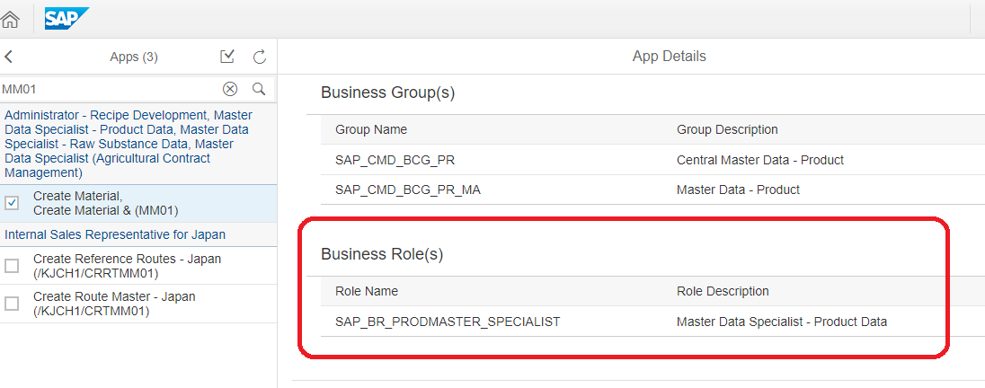

Addin to the user specific role with Business group/business catalog or adding the broad standard role to the user should fix the issue.

For specific catalog/group, you should also :

1. Run Transaction **/n/iwbep/cache_cleanup** in the backend ABAP system.

Select the checkbox and execute.

2. Run Transaction **/n/iwfnd/cache_cleanup** in the frontend ABAP system.

Select the checkbox and execute.

report **/UI2/DELETE_CACHE_AFTER_IMP**

report **/UI2/DELETE_CACHE**

report **/UI2/INVALIDATE_GLOBAL_CACHES** => to refresh PFCG

report **/UI2/CHIP_SYNCHRONIZE_CACHE**

report /UI5/APP_INDEX_CALCULATE

Close the browser and try again.

Part 3 : app issue

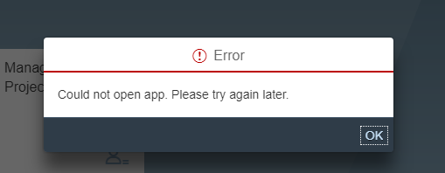

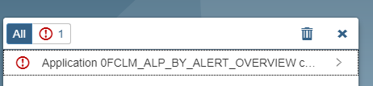

For any error message, button not working or tile grayed, you should first follow this process :

1. Check transaction **/n/IWFND/ERROR_LOG** and **ST22** in frontEnd System for any error for the user
2. Check transaction **/n/IWBEP/ERROR_LOG** and **ST22** in backEnd System for any error for the user
3. Close the browser, open it again in private mode, and before the error/lock appends, press F12 to open the browser console

In the screen press the « Network button » and in the list check for any red line :

I

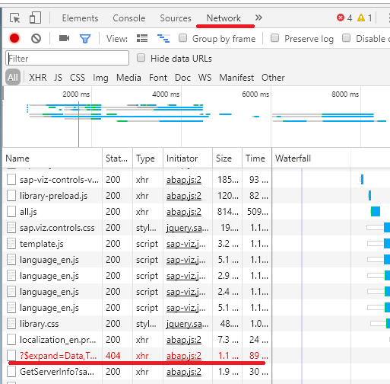

Pressing the line you can see the response the system sent and see what kind of error was sent.

For instance :

{"error":{"code":"/IWFND/MED/170","message":{"lang":"en","value":"No service found for namespace '', name '**O2C_CI_INVDOC_DISPLAY_SRV**', version '0001'"}[…]}}

This error imply that the service **O2C_CI_INVDOC_DISPLAY_SRV** is probably not active on the frontEnd System.

Sometime the error won’t be straiforward in the response :

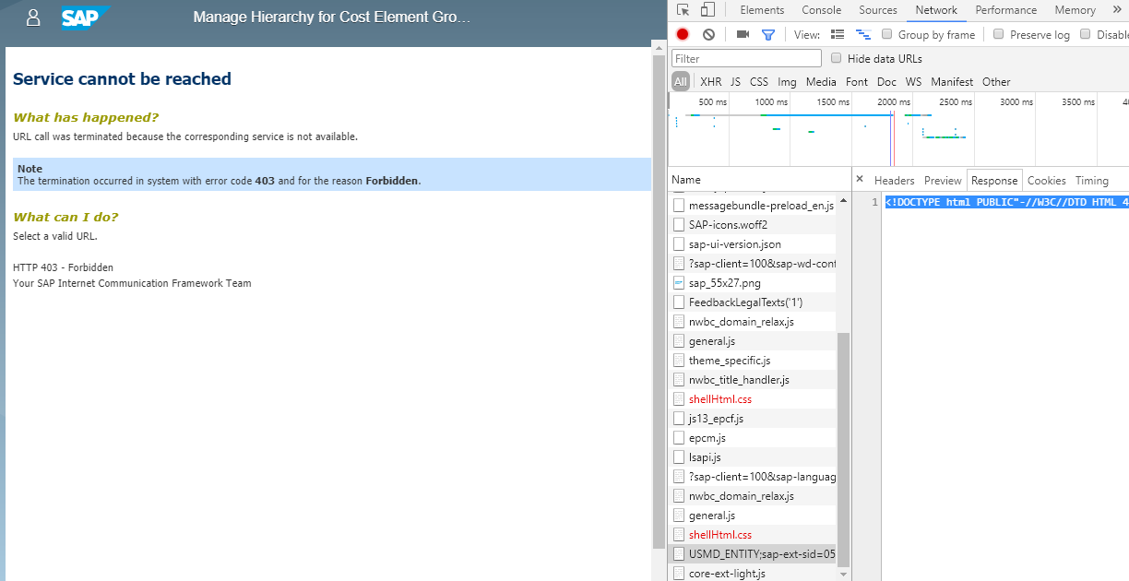

In this case we have a 403 Forbidden error and we can identify the url :

<https://unity-int.jcdecaux.com/sap/bc/webdynpro/sap/USMD_ENTITY;sap-ext-sid=051MexWc7jU>[...]

and search for the service in SICF in backend and FrontEnd :

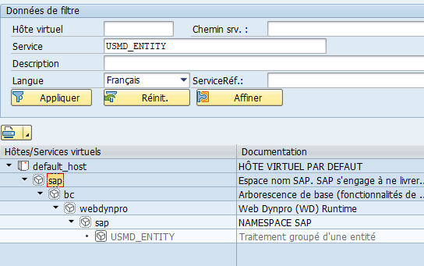

In this case, you must activate the service

Part 4 : data issue :

In the case when the service is working properly but you want to check where does the data comes from :

Open the app with the browser developer console open (F12), and search for the request, in the network tab, that sent the data you want to check

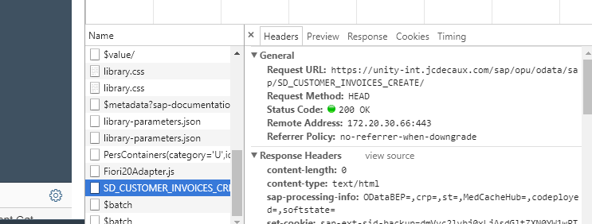

In this case we can see that the source of the data is from the URL :

<server>/sap/opu/odata/sap/SD_CUSTOMER_INVOICES_CREATE/

So we must check the Odata Service SD_CUSTOMER_INVOICES_CREATE that must exist in the Backend.

In the backend, open the transaction SEGW and press the folder button

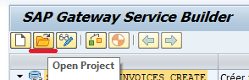

And open SD_CUSTOMER_INVOICES_CREATE

At this point you can add session breakpoint in the classes to troubleshoot the issues

For instance, in the Runtime Artifact folder, open class CL_SD_CI_CREATE_DPC by double clicking on the name of the class.

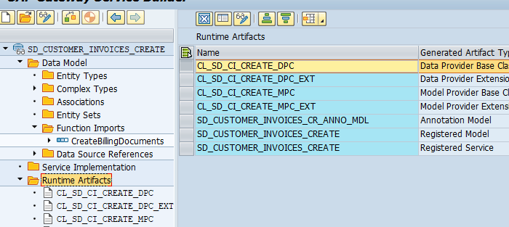

Then search for method /IWBEP/IF_MGW_APPL_SRV_RUNTIME~GET_ENTITYSET

And in the method, put a session Breakpoint at the first line

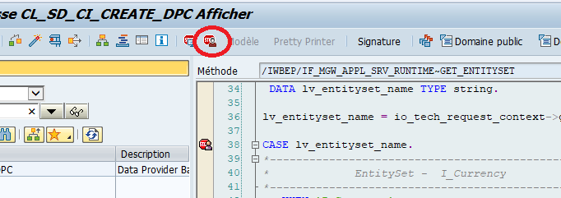

Then when you call the app again, a debug popup should be openend.